**Five Stage Ring Oscillator**

Schematic

Schematic for Five Stage Ring Oscillator:

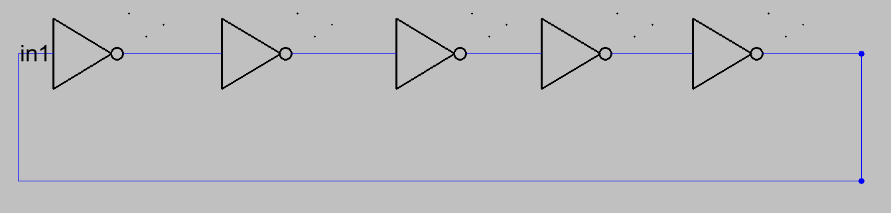

Layout

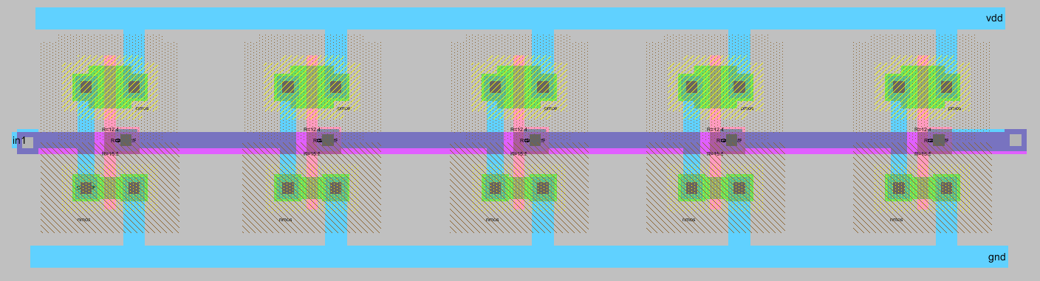

SPICE Code

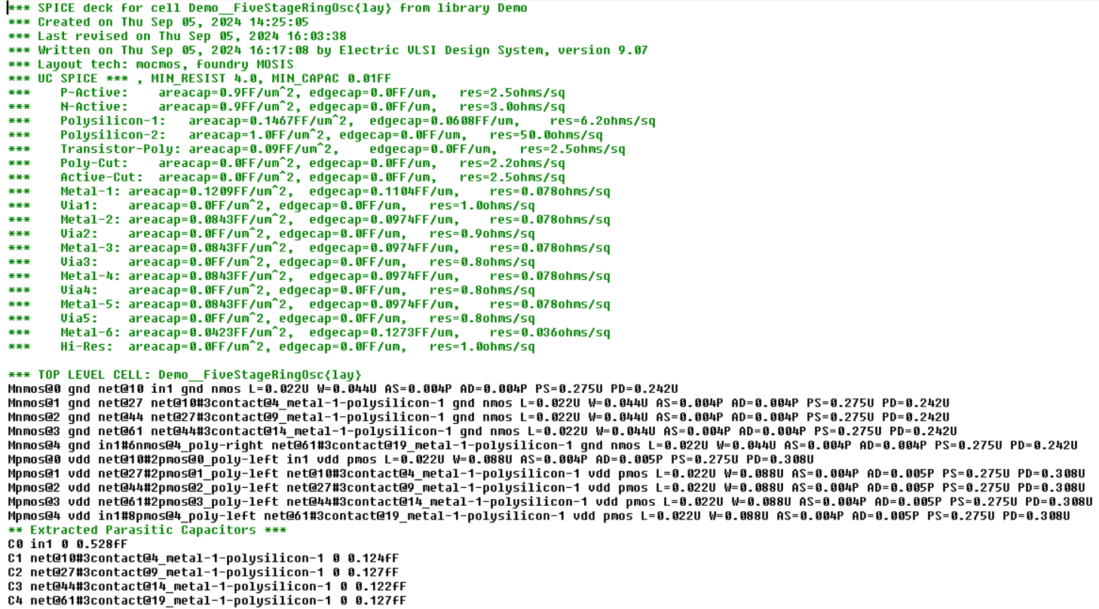

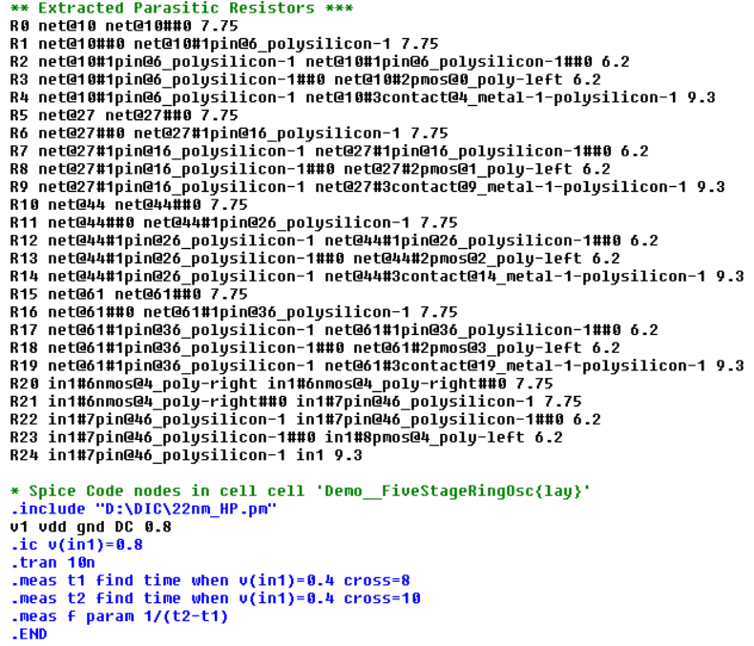

DRC:

Running DRC with area bit on, extension bit on, Mosis bit

Checking again hierarchy .... (0.0 secs)

Found 18 networks

Checking cell 'Demo__FiveStageRingOsc{lay}'

No errors/warnings found

0 errors and 0 warnings found (took 0.042 secs)

LVS:

Hierarchical NCC every cell in the design: cell 'FiveStageRingOsc{sch}' cell 'Demo__FiveStageRingOsc{lay}'

Comparing: Demo:FiveStageRingOsc{sch} with: Demo:Demo__FiveStageRingOsc{lay}

exports match, topologies match, sizes match in 0.003 seconds.

Summary for all cells: exports match, topologies match, sizes match

NCC command completed in: 0.003 seconds.

Measurement:

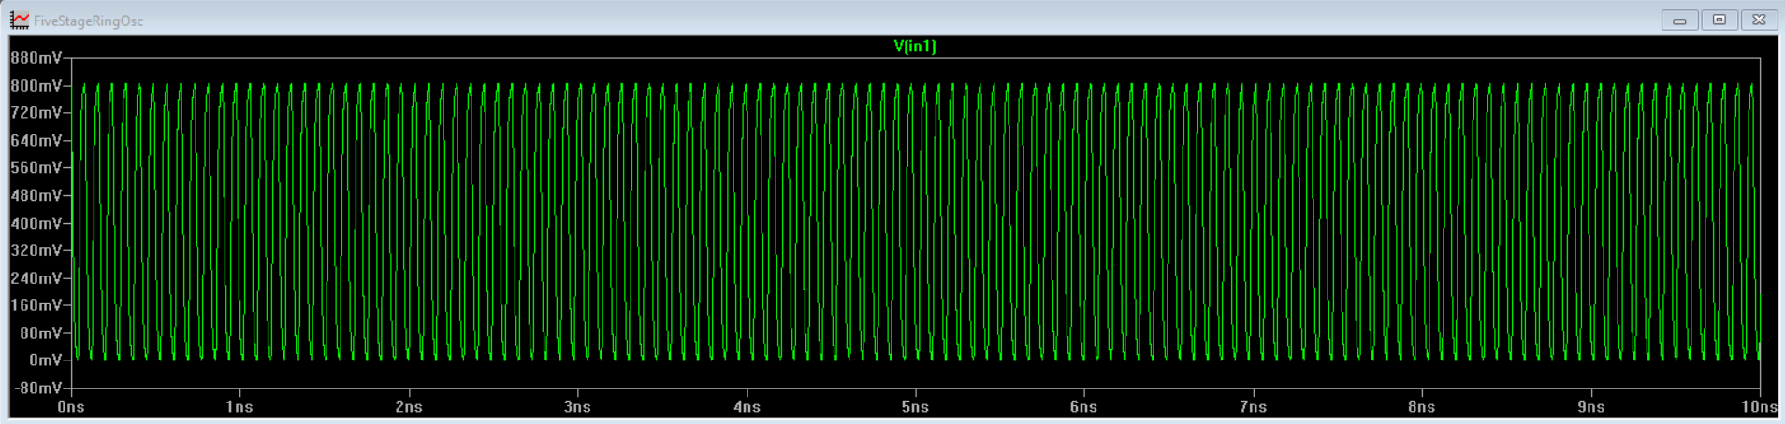

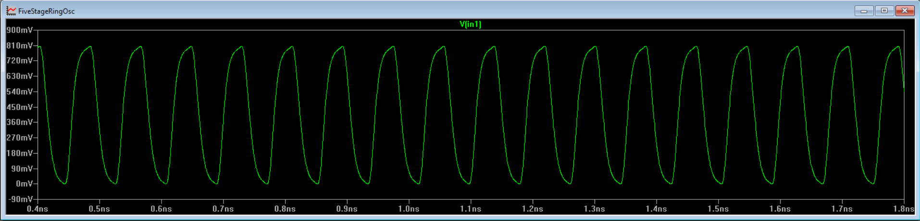

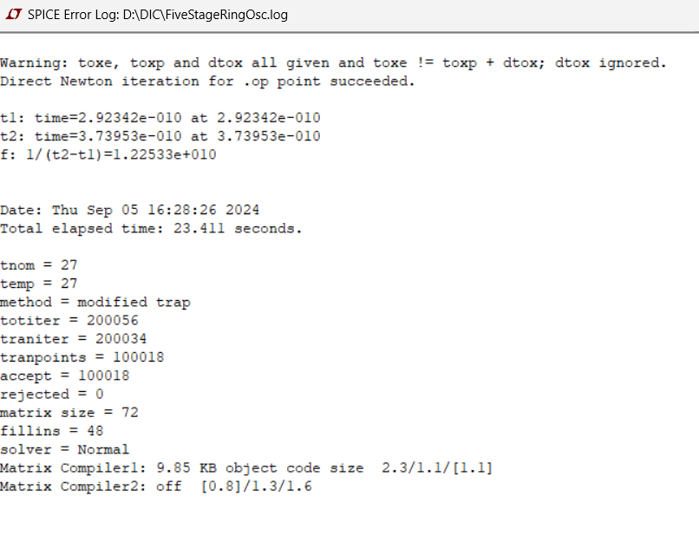

Stretch Experiment:

Monte-Carlo:

ID vs t for the Monte-Carlo:

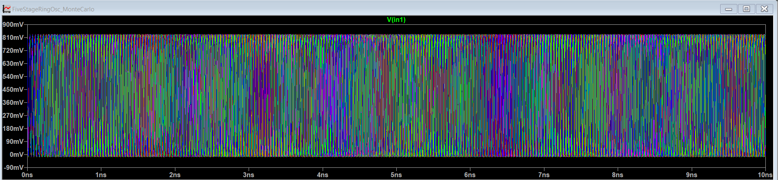

Error Log – Chk Text file